**Modeling and Simulation of Grid-Connected Solar PV-Based Level 3 DC Fast Charger Using DAB Converter**

*A report submitted in partial fulfillment of the requirements for the Award of Degree of*

**Bachelor of Technology**

**In**

**Electrical Engineering**

Submitted By:

Sudipta Mohanty(2111100231)

Ganesh Jani(2111100227)

Ranbir Das(2111100316)

Under the Guidance of: **Mrs. Moningi Srivalli Assistant Professor, SES**



**SCHOOL OF ELECTRICAL SCIENCES**

**ଓଡ଼ିଶା ବୈଷୟିକ ଓ ଗବେଷଣା ବିଶ୍ବବିଦ୍ୟାଳୟ**

**ODISHA UNIVERSITY OF TECHNOLOGY AND RESEARCH, BHUBANESWAR- 751029**

**2025**

**ଓଡ଼ିଶା ବୈଷୟିକ ଓ ଗବେଷଣା ବିଶ୍ବବିଦ୍ୟାଳୟ**

**ODISHA UNIVERSITY OF TECHNOLOGY AND RESEARCH**

Ghatikia, Bhubaneswar-751029

**School of Electrical Sciences**

**---------------------------------------------------------------------------------------------------------------------------**



**CERTIFICATE**

This is to certify that the project report entitled **“Modeling and Simulation of Grid-Connected Solar PV-Based Level 3 DC Fast Charger Using DAB Converter”** submitted by *Sudipta Mohanty(2111100231),Ganesh Jani(2111100227),Ranbir Das(2111100316)* of School of Electrical Sciences, fulfils the requirement of the regulation relating to the nature and standard of the work for the award of the degree of Bachelor of Technology, in Electrical Engineering for academic year 2024-25.

**HOS**

**School of Electrical Sciences Supervisor**

ଓଡ଼ିଶା ବୈଷୟିକ ଓ ଗବେଷଣା ବିଶ୍ବବିଦ୍ୟାଳୟ

**ODISHA UNIVERSITY OF TECHNOLOGY AND RESEARCH**

Ghatikia, Bhubaneswar-751029

**School of Electrical Sciences**

**---------------------------------------------------------------------------------------------------------------------------**



**DECLARATION**

We do hereby declare that, the minor project entitled, “**Modeling and Simulation of Grid-Connected Solar PV-Based Level 3 DC Fast Charger Using DAB Converter**” is a bona-fide work of study carried out by us under the guidance of **Mrs. Moningi Srivalli***,* Assistant Professor*,* School of Electrical Sciences, Odisha University of Technology and Research, Bhubaneswar. It has been prepared for the fulfilment of the requirements of the degree of ‘Bachelor of Technology in Electrical Engineering’. The work has not been submitted for any other purpose.

PLACE: Bhubaneswar Sudipta Mohanty (2111100231)

Ganesh Jani (2111100227)

DATE:

Ranbir Das (2111100316)

**ACKNOWLEDGEMENT**

We are really indebted and want to specific my feeling to my supervisor **Mrs. Moningi Srivalli***,* Assistant Professor for her inspiration, glorious steering, continued encouragement, and unwavering confidence and support throughout each stage of this endeavour while not that, it might not be doable on behalf of me to finish this endeavour with success. we additionally give thanks for her perceptive comments and suggestions that regularly helped to boost my understanding and knowledge.

We are additionally significantly duty-bound to the Head of the School of Electrical Sciences **Dr. Lokanath Tripathy**, Odisha University of Technology and Research, Bhubaneswar for providing all doable facilities towards my research work. We’d wish to due to all different university members within the department.

We whole hearted feeling to my parents and friends for their constant encouragement, love, desires, & support. Above all, we give thanks to almighty who bestowed blessings upon us.

Sudipta Mohanty (2111100231)

Ganesh Jani (2111100227)

Ranbir Das (2111100316)

**ABSTRACT**

The increasing adoption of electric vehicles has created a critical demand for high-speed, energy-efficient charging systems that can reduce charging times while maintaining grid stability. This project focuses on the modeling and simulation of a grid-connected solar-powered fast charging station, designed to deliver high-power direct current (DC) output suitable for rapid electric vehicle charging. The system integrates a photovoltaic (PV) array with a multi-stage power conversion interface to ensure clean energy utilization and reduced reliance on the conventional power grid.A maximum power point tracking (MPPT) algorithm is employed to optimize the energy extracted from the solar array under dynamic weather conditions. The final stage of the charging system uses a dual active bridge (DAB) converter to regulate the power transfer to the electric vehicle battery. This converter provides galvanic isolation, supports high-frequency operation, and enables efficient bidirectional energy flow. Power transfer is controlled through the phase shift between the square wave voltages generated on the primary and secondary sides of the converter.The inductor current between the two bridges exhibits a near-triangular waveform, influenced by the voltage difference, switching frequency, and phase shift angle. Simulation studies are performed in MATLAB/Simulink to analyze voltage stability, energy flow, and system efficiency under various solar irradiance and load conditions. The system successfully converts a 415-volt root mean square (RMS) grid input to a regulated 400-volt DC output suitable for fast charging applications.This project demonstrates a robust and scalable solution for integrating renewable energy into electric vehicle charging infrastructure. The combination of solar energy with advanced power conversion not only reduces environmental impact but also improves the performance and flexibility of next-generation charging systems. The results validate the proposed architecture’s suitability for sustainable and intelligent transportation networks.

**LIST OF ABBREVIATIONS**

1. EVs Electric Vehicles
2. G2V Grid-to-Vehicle
3. V2G Vehicle-to-Grid
4. SOC State of Charge
5. UPS Uninterruptible Power Supply
6. PWM Pulse Width Modulator
7. PI Proportional Integral
8. THD Total Harmonic Distortion
9. EMI Electro Magnetic Interference
10. OCV Open Circuit Voltage
11. CC Constant Current
12. CV Constant Voltage
13. PLL Phase Locked Loop
14. FM Frequency Modulation
15. DQ Direct-Quadrature

**LIST OF FIGURES**

**Figure No. Figure Caption Page No.**

2.1 Comparison chart between charging types 9

2.2 Block diagram of the entire system 11

2.3 Three phase Rectifier with LCL filter 13

2.4 Direction of the magnetic axes of the stator in the abc reference 14 frame and the stationary αβ0 reference frame

2.5 *α*, *β*, and zero components in the stationary reference frame 14

2.6 *α-β* axes components in an *αβ* reference frame and rotating 15

*dq* reference frame

2.7 Direction of the magnetic axes of the stator windings in an  16

*abc* reference frame and a rotating *d*-*q* reference

2.8 Boost Converter module with MPPT Algorithm 19

2.9 Circuit configuration of DAB dc-dc converter 21

3.1 Output Voltage of 3 Phase Rectifier 25

3.2 Primary, Secondary Voltage and Inductor Current 26

3.3 Output Voltage of DAB Converter 27

3.4.a Battery voltage 28

3.4.b Battery Current 28

**TABLE OF CONTENT**

**Title Page No**

CERTIFICATE ii

DECLARATION iii

ACKNOWLEDGEMENT iv

ABSTRACT v

LIST OF ABBREVIATIONS vi

LIST OF FIGURES vii

CHAPTER 1: INTRODUCTION

1.1: Background 1

1.2: Motivation 2

1.3: Literature Review 3

1.4: Problem Definition 6

CHAPTER 2: THEORY

2.1 EV CHARGING TECHNOLOGY 7

2.1.1 Charging modes 7

2.1.1a Level 1charging 7

2.1.1b Level 2 charging 8   
 2.1.1c Level 3 charging 8

2.2 System Configuration 10

2.3 Block Diagram 11

2.4 Methodology 12

2.4.1 Three Phase Rectifier 12

2.4.2 Role of Input Filter 13

2.4.3 Control Technique 14

2.5 PV System 17

2.6 Boost Converter 18

2.6.1 MPPT Algorithm 18

2.7 Dual Active Bridge Converter 19

2.7.1 Design Considerations 21

2.7.1.1 Leakage Inductor 21

2.7.1.2 Phase Shift 22

2.7.1.3 Effect of Inductance 22

2.7.1.4 Switching Frequency 23

2.8 Constant Current Constant Voltage Charging 24

CHAPTER 3: RESULTS AND RESULT ANALYSIS 25

CHAPTER 4: CONCLUSION AND FUTURE SCOPES 29

# 

# REFERENCES 31

# **CHAPTER 1: INTRODUCTION**

**1.1 BACKGROUND**

The rapid global shift toward electric vehicles (EVs) is reshaping modern transportation. Rising concerns over greenhouse gas emissions, fossil fuel depletion, and urban air pollution have positioned EVs as a cleaner, more sustainable alternative to internal combustion engine (ICE) vehicles. Governments, industries, and consumers alike are accelerating EV adoption, with global sales rising significantly. However, the success of this transition depends not just on vehicle technology, but also on the efficiency and sustainability of the supporting charging infrastructure.[1]

EV chargers are typically classified into Level 1, Level 2, and Level 3 (DC fast charging). While Level 1 and 2 chargers cater to residential and workplace needs, their lower power output leads to longer charging times. In contrast, Level 3 chargers significantly reduce charging duration by supplying high-power direct current (DC) directly to the vehicle’s battery, making them ideal for commercial fleets and long-distance travel where downtime must be minimized.[2]

To further improve sustainability, renewable energy sources such as photovoltaic (PV) solar power are being increasingly integrated into EV charging systems. In this project, the majority of charging power is drawn from a PV system, making the charging process more eco-friendly and reducing dependence on grid electricity. This also lowers the carbon footprint associated with EV operation and supports the transition to clean energy.[3]

Addressing the high power conversion and control requirements of DC fast charging, this system employs a Dual Active Bridge (DAB) DC-DC converter. The DAB offers high efficiency via soft switching, galvanic isolation, and bidirectional power flow, aligning well with advanced applications such as Vehicle-to-Grid (V2G). By integrating PV power and DAB-based conversion, the proposed system supports reliable, high-performance, and sustainable fast charging—suitable for future smart grid and microgrid environments.

**1.2 MOTIVATION**

As electric vehicles (EVs) continue to gain traction globally, the supporting infrastructure must evolve to keep pace with growing demand. One of the most significant barriers to widespread EV adoption remains the challenge of slow and inconsistent charging. Although EV technologies have matured rapidly, many users still face concerns such as range anxiety and long charging times—especially in regions lacking robust infrastructure or in commercial sectors where vehicles must remain operational throughout the day.

Addressing this issue calls for the development of efficient and high-speed charging systems. Level 3 DC fast charging, which can replenish a vehicle’s battery in under an hour, is essential to meeting the expectations of modern EV users. However, this capability comes with high technical demands: systems must support rapid energy transfer, minimize power losses, and offer electrical isolation and flexibility in operation.

A promising solution lies in the use of Dual Active Bridge (DAB) DC-DC converters, which offer advantages such as high-frequency operation, soft-switching for reduced losses, galvanic isolation, and the ability to transfer energy bidirectionally. These features not only improve charging efficiency and system compactness but also prepare the infrastructure for future Vehicle-to-Grid capabilities, enabling EVs to support the power grid during peak loads.

To further enhance sustainability, this charging system is designed to draw the majority of its power from a photovoltaic (PV) array, integrating renewable energy into the EV ecosystem. By utilizing solar energy as the primary power source, the system reduces reliance on conventional grid electricity and minimizes environmental impact, making it a cleaner and more sustainable charging solution. The grid remains available as a secondary support, ensuring reliability when solar generation fluctuates.

**1.3 LITERATURE REVIEW:**

|  |  |  |  |  |
| --- | --- | --- | --- | --- |
| Author | Paper Name/  Date of Publish | Description | Methodology | Research  Gap |
| [M. Liserre](https://ieeexplore.ieee.org/author/37272424200); [F. Blaabjerg](https://ieeexplore.ieee.org/author/37278889300); [S. Hansen](https://ieeexplore.ieee.org/author/37273402000) | Design and control of an LCL-filter-based three-phase active rectifier [1]  Published:IEEE Xplore sept.-oct. 2005 | The problem involves designing an LCL filter for a three-phase active rectifier to minimize switching frequency ripple, ensuring grid current quality.. | Involves achieving dynamic response in filtering action,verified using MATLAB simulation | In this study includes the lack of a systematic LCL filter design procedure, reliance on trial-and-error methods, and limited experimental validation. |
| [K. Chaijarurnudomrung](https://ieeexplore.ieee.org/author/37704863900); [K-N. Areerak](https://ieeexplore.ieee.org/author/37545847700); [K-L. Areerak](https://ieeexplore.ieee.org/author/37545847600) | Modeling of three-phase controlled rectifier using a DQ method[2]  IEEE *Xplore*: 26 August 2010 | The problem is the time-varying nature of power converter models due to switching actions, making analysis and control difficult. A DQ modeling method is proposed to achieve a time-invariant model | The methodology involves using the DQ modeling method to transform the time-varying power converter model into a time-invariant form all done using MATLAB simulation | The future goals include extending the DQ modeling approach for larger and more complex power systems, conducting experimental validation to confirm simulation results, and analyzing system behavior |
| [Muhammad Zarkab](https://ieeexplore.ieee.org/author/37088812746); [Bhim Singh](https://ieeexplore.ieee.org/author/37089309438); [B.K Panigrahi](https://ieeexplore.ieee.org/author/37301106400) | Bi-Directional Isolated EV Charger with Reduced Switch Count and DC-link Capacitance”, 2021 IEEE 6th International Conference on Computing, Communication and Automation (ICCCA)[3] | The problem involves the conventional isolated EV battery charger using a bulky DC-link capacitor and 12 switches, leading to increased size and complexity. This study proposes a single-stage Dual-Active Bridge (DAB) with reduced capacitance and fewer switches to achieve improved power factor and efficient energy transfer | The methodology involves designing a single-stage DAB converter with unipolar modulation and ZVS analysis, verified using MATLAB simulations. | Future improvements include experimental validation for real-world performance, optimizing converter efficiency, and enhancing control strategies for better operation under varying load and grid conditions |
| Ansam B. El-Fawair, Kasim M. Al-Aubidy and Mustafa A. Al-Khawaldeh | "Energy Management in Microgrids with Renewable Energy Sources and Energy Storage System" [6]  Published in:  IEEE Xplore 6 February 2024 | Effective energy management in microgrids integrates renewable energy sources and energy storage systems to ensure reliable, sustainable power. Advanced control strategies optimize energy flow, balance supply and demand, and enhance grid resilience, reducing costs and environmental impact. | Intermittent renewable energy sources and complex energy storage management in microgrids cause unreliable power supply, inefficient energy use, and high costs, necessitating advanced control strategies to optimize energy flow, ensure grid stability, and enhance resilience. | Few studies integrate intelligent control, load priority, price fluctuations, and random renewable generation for cost-effective, reliable microgrid EMS. |
| Hu Huihui et al. | Fault-tolerant Control of BESS[7] (IEEE IPEMC, 2024) | Internal module faults affecting SOC balance. | Simulation using cascaded H-Bridge topology. | Limited practical validation of fault scenarios. |
| Chengdong Jiang et al. | Grid Short-Circuit Faults with Storage[8]  (IEEE ICPEA, 2024) | Impact of grid faults on BESS operation. | Grid-forming vs. grid-following inverter simulations. | Practical scenario applications and validations needed. |
| Zhicheng Li et al. | Battery Module Short-circuit Faults[9]  (IEEE HVDC, 2024) | Effects of internal short circuits on module performance. | Single-stage converter simulation and fault analysis. | Detailed study of load redistribution under faults lacking. |

**1.4 PROBLEM STATEMENT**

Conventional EV chargers are often slow and inefficient, making them impractical for users who require fast turnaround, especially during long-distance travel. This limitation not only affects the convenience of EV ownership but also poses a barrier to the broader acceptance and scalability of electric mobility. The extended charging duration undermines the efficiency and appeal of EVs when compared to conventional fuel-based vehicles. To address this issue, there is a critical need for advanced charging technologies that can significantly reduce charging time without compromising performance or safety. This project identifies the problem of slow EV battery charging and proposes to solve it by developing a fast-charging system that incorporates a Dual Active Bridge (DAB) converter with a Solid-State Transformer (SST), aiming to enable faster, efficient, and more practical charging solutions.

**CHAPTER 2: THEORY**

**2.1 Electric vehicle charging technology**

EV charging stations are basically refueling stations for electric vehicles that are placed at strategic locations to ensure they are available to be used whenever necessary. The charging point is connected to the charging panel through a cable and the panel contains the user interface which is accessed by the users of the charging station. Depending on the grid, various parameters such as the voltage and outlet configuration determine the power output of the charger.  
Of the various known standards of electric vehicle charging, type 1 and type 2 are the most known types of charging where as type 3 DC fast charging is a relatively newer technology.

**2.1.1 Charging Modes**

**2.1.1.a Level 1 charging**Level 1 (L1) chargers are especially useful for people who have access to charging points at work or school, allowing them to top up their electric vehicles (EVs) throughout the day.

However, since L1 charging is quite slow, EV drivers often refer to it as a emergency charger rather than a primary charging solution. L1 chargers use standard household outlets, which run at 120V and deliver up to 16 amps of current.

This setup provides a maximum power output of about 1.9 kW, meaning it can take anywhere from 8 to 16 hours to fully charge a battery, depending on its size. While L1 charging isn’t ideal for long commutes or road trips, it’s a convenient option for overnight charging at home or for keeping your battery topped up when parked for long hours at work or school.

**2.1.1.b Level 2 charging**Level 2 (L2) charging stations are the most prevalent choice for both public and residential EV charging which offer a much faster alternative to Level 1 chargers. To meet L2 requirements, these stations use a 240V single-phase power supply with a maximum current of 40A for home and commercial setups. Public charging stations, on the other hand, often rely on a three-phase 400V AC power supply with up to 80A of current for higher power output and much higher efficiency.

L2 chargers are found in a variety of locations, from parking and business entrances to schools and colleges, where employees and students can conveniently charge their vehicles.

The maximum charging power of L2 chargers is around 12 kW. An L2 charger can add roughly 100 miles of range in about seventeen to eighteen hours, making it a great option for daily charging. Plus, L2 charging systems come with built-in safety options for overcurrent and overvoltage protection, ensuring safe and reliable operation.

**2.1.1.c Level 3 DC fast charging**

Level 3(L3) is the fastest charging method for electric vehicles. This type of charger is typically used in public and commercial areas where faster charging time is the most preferred. Due to the rapid fast charging speed, vehicles can be recharged quickly in high traffic and perennially busy areas.

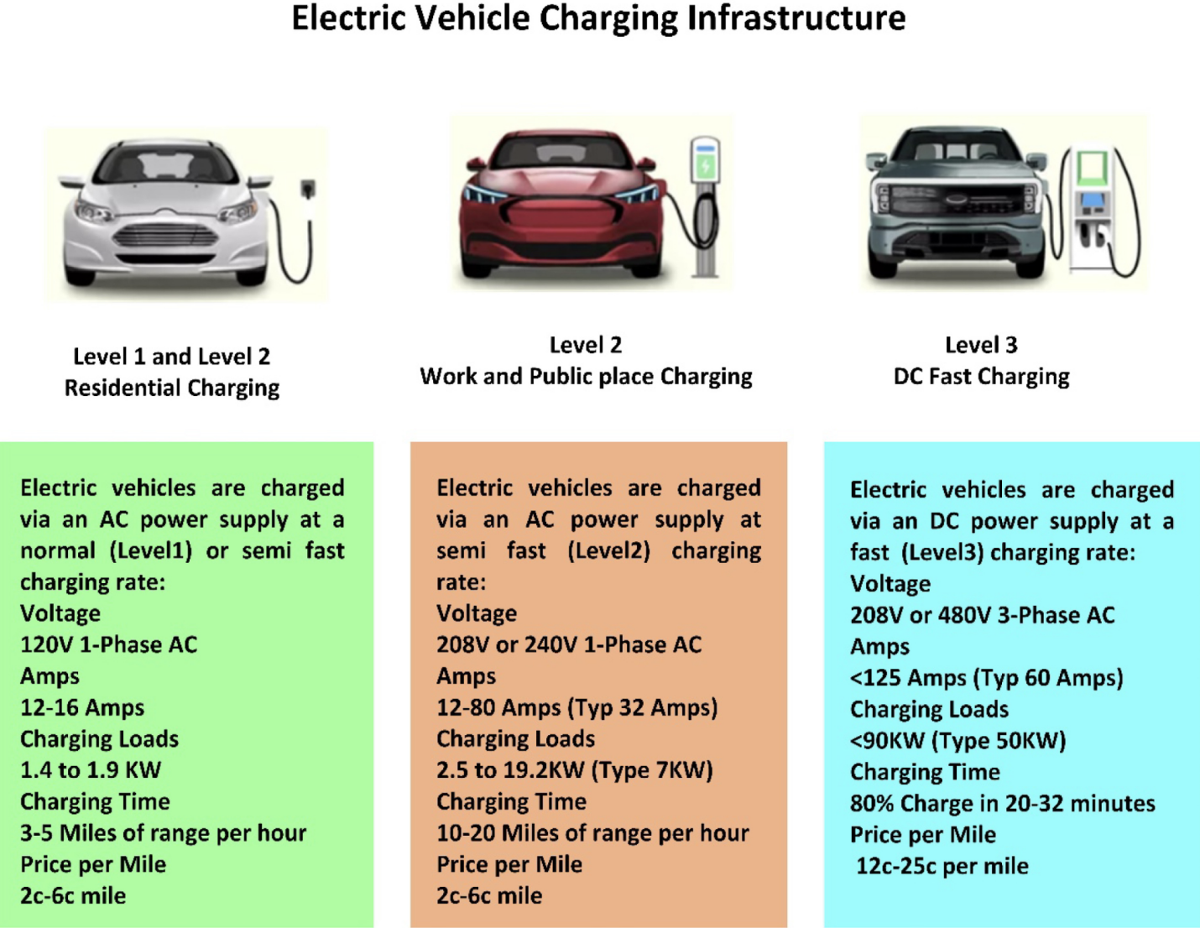In addition, L3 chargers do not comply with industry standards and are not universally compatible. By using DC charging technology, these stations are designed to provide a similar user experience to that of traditional filling stations. The charge time for a battery from 0 to 80% is usually 15 to 20 min with DC fast charging. All 20% of the remaining battery will always be charged in slow mode, regardless of the charging level.

DC power is delivered to the electric vehicle by converting AC power from an off-board charger. Charging voltages for L3 typically range from 200 to 600 V, and power outpots range from 36 to 240 kW. Most DC power output charging stations are located in malls, government buildings, movie theaters, [airports](https://www.sciencedirect.com/topics/engineering/airfield), and refueling stations. Level 3 DC fast-charging stations have a significant drawback due to their high installation costs.



**Fig.2.1: Comparison chart between charging types[3]**

**2.2 SYSTEM CONFIGURATION**

The system configuration for Level 3 DC fast charging in this project is designed to enable high-power, high-efficiency energy transfer from the grid to an electric vehicle battery. The configuration begins with a three-phase AC input, typically sourced from the utility grid, which is rectified using a three-phase controlled rectifier. This stage is crucial for converting the high-voltage AC supply (commonly 400 V or 415 V, 50/60 Hz) into a stable DC voltage. The three-phase rectifier is preferred due to its ability to handle high power loads with better ripple performance and improved efficiency compared to single-phase rectifiers. The output of the rectifier serves as the DC-link that feeds the Dual Active Bridge (DAB) converter, which is the central power conversion element in the system.

The DAB converter provides galvanic isolation, soft-switching operation, and bidirectional power flow, making it highly suitable for fast-charging applications. It operates at a high switching frequency, allowing for reduced transformer size and improved power density. The two active bridges—on the input and output sides—enable efficient power transfer through a high-frequency transformer. On the output side, the DAB converter regulates voltage and current precisely to charge a 300 Ah battery. The charging profile is managed to ensure safety and efficiency, typically following constant current (CC) and constant voltage (CV) phases depending on the battery’s state of charge.

This system configuration is scalable and modular, allowing for parallel operation of multiple DAB converters to increase power throughput if needed. It also supports future Vehicle-to-Grid (V2G) capabilities thanks to the DAB's bidirectional nature, enabling power flow back to the grid when required. Overall, the integration of a three-phase rectifier with a DAB converter offers a compact, efficient, and high-performance solution for Level 3 DC fast charging, significantly reducing the charging time for large-capacity EV batteries while ensuring system reliability and grid compatibility.

**2.3 BLOCK DIAGRAM**

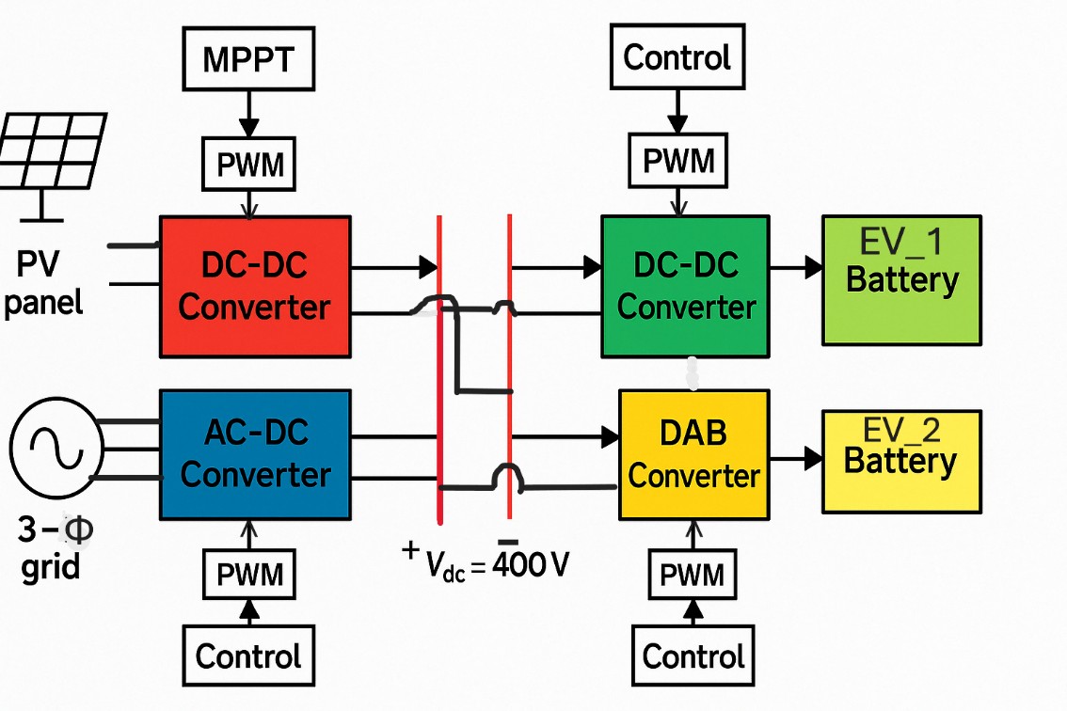

**Fig.2.2 Block diagram of the entire system**

The proposed system architecture is designed to facilitate efficient DC fast charging with integrated renewable energy and energy storage. It begins with an AC bus, representing the input from the microgrid or utility grid. From the AC bus, power is fed into a three-phase controlled rectifier, which converts AC voltage into DC. This stage serves as the primary interface between the grid and the DC charging infrastructure, ensuring reliable and controllable power conversion.

The output of the rectifier is connected to a centralized DC bus, which acts as the backbone of the DC distribution network. This DC bus enables flexible interconnection of various power converters, distributed energy resources, and storage systems. A photovoltaic (PV) array is also connected to the DC bus via a DC-DC boost converter, allowing renewable solar energy to supplement or offset grid power usage.From the DC bus, power is routed through a Dual Active Bridge (DAB) converter, which facilitates bi-directional power transfer with the main battery energy storage system. The DAB provides galvanic isolation, voltage matching, and efficient energy exchange. Additionally, a secondary battery is interfaced to the DC bus using a buck-boost converter, allowing for dynamic voltage regulation and energy balancing. This architecture enhances system flexibility, sustainability, and reliability.

**2.4 METHODOLOGY**

**2.4.1 Three Phase Rectifier**

Incorporating a three-phase rectifier as the first stage of the project is a crucial aspect of Level 3 DC fast charger design. This rectifier is responsible for converting the AC input from the grid into DC, which can be further transformed and controlled to charge electric vehicle batteries efficiently.

AC-DC converters with regulated outputs are commonly used as the front-end stage for feeding DC-DC converters. In high-power applications, using three-phase rectifiers is beneficial, especially when combined with active power factor correction techniques to improve efficiency and ensure better alignment with the input AC supply.

The three-phase rectifier plays an important role in the overall design, and its performance significantly impacts the efficiency and effectiveness of the Level 3 DC fast charger. Several key functions which highlight the importance of this initial stage are as follows:

* **AC to DC Conversion:** The three-phase rectifier is responsible for the conversion of the grid's AC power into DC power, a critical step in the charging process. This conversion is essential as electric vehicles primarily rely on DC power for charging their batteries.
* **Power Factor Correction:** Efficient power factor correction is vital in ensuring that the charger operates harmoniously with the grid. The three-phase rectifier is instrumental in this regard, helping to achieve a unity power factor or close to it. This not only minimizes energy losses but also reduces the impact of the charger on the grid's power quality.
* **Ripple Reduction:** The rectifier stage also contributes to reducing ripple and harmonics in the DC output voltage. This is essential for the safe and efficient charging of EV batteries, as excessive ripple can lead to heat generation and potential damage to the batteries.
* **Grid Compatibility:** The rectifier facilitates smooth interaction between the charger and the grid, ensuring that the charger complies with grid standards and with power quality issues like minimizing the disruptions, and avoids voltage sags or swells.

**2.4.2 Role of an input filter:**

We have used an LCL (Inductor-Capacitor-Inductor) filter as an input filter before the rectification stage to improve overall performance of the system.

Here are some key reasons for incorporating LCL filter:

1. **Harmonic Mitigation:** One of the primary reasons for using an input LCL filter is to reduce and mitigate harmonics in the current waveform. Rectifiers operating without filtering can generate harmonics in the input current due to the non-linear nature of the rectification process. These harmonics can have detrimental effects on the electrical grid, potentially causing power quality issues and compliance problems with grid regulations. The LCL filter is designed to attenuate these harmonics, resulting in a cleaner and more sinusoidal input current.
2. **Damping of voltage spikes:** Voltage spikes, inherent to switching transitions during rectification, can pose a threat to the system and its components. The LCL filter's inductor component plays a crucial role in damping these voltage spikes, ensuring system protection and longevity.

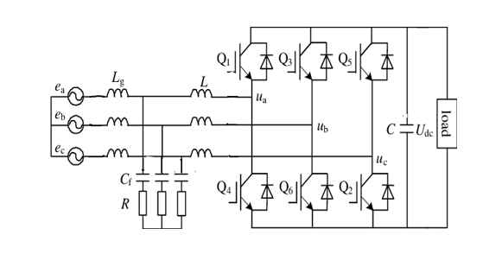

**Fig.2.3 Three phase Rectifier with LCL filter**

**2.4.3 Control Technique:**

We implemented a multi-stage transformation process for generating pulses to drive the IGBTs used in the rectifier.

**Step1: ABC to αβ0 Transformation**  
The first stage involves converting the three-phase signals (ABC) into the αβ reference frame using the Clarke Transformation. This step is essential for analyzing and controlling three-phase systems such as rectifiers.

The Clarke Transform block translates the time-domain signals from the ABC frame to a stationary αβ0 frame. A power-invariant form of the transform is used to ensure that the active and reactive power in the αβ0 frame matches that of the original ABC system. In a balanced system, the zero-sequence component becomes zero.

|  |  |
| --- | --- |
| abc.png  **Fig 2.4 Direction of the magnetic axes of the stator windings in the abc reference frame and the stationary αβ0 reference frame.** | alphabetaaxes.png  **Fig 2.5 *α*, *β*, and zero components in the stationary reference frame.** |

The primary objectives of this transformation are:

* **Simplifying Analysis:** The ABC to αβ transformation simplifies the mathematical analysis of the three-phase variables by projecting them onto a two-dimensional plane. This simplification eases the design and control of the rectifier.
* **Decoupling Variables:** By transforming to the αβ frame, the direct (α) and quadrature (β) components of the three-phase system are separated. This decoupling allows for independent control of real power (P) and reactive power (Q).

**Step 2: αβ to DQ Transformation**After completing the ABC to αβ transformation, the next step is to convert the αβ components into the DQ reference frame. In this frame, D represents the direct axis and Q represents the quadrature axis. This transformation is carried out using an Alpha-Beta-Zero to DQ0 block.

The Alpha-Beta-Zero to DQ0 block transforms the αβ0 components from the stationary Clarke reference frame into DQ0 components in the rotating Park reference frame. This conversion simplifies control and analysis of AC systems by aligning the reference frame with the rotating vector of the system, making it easier to manage variables like torque and flux.

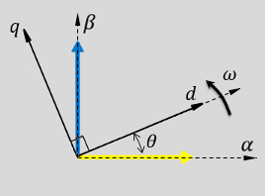

**Fig 2.6 *α-β* axes components in an *αβ* reference frame and rotating *dq* reference frame**

**D-axis Current Control**: The D-axis is aligned with the direct current (DC) component, allowing for precise control of the DC link voltage. This is crucial for regulating the output voltage and ensuring a constant, well-controlled charging voltage for electric vehicles.

**Q-axis Current Control**: The Q-axis control is useful for achieving power factor correction. By manipulating the Q-axis current, the rectifier can minimize reactive power and improve the overall power factor of the system.

**Step 3: DQ to ABC Transformation:**

After performing the PI control on VD, VQ and ID, IQ in the DQ frame, the transformed signals are converted back to the ABC reference frame to generate the PWM signals. This conversion is necessary for practical implementation, as the PWM modulation signals must be in the three-phase ABC format

.The Inverse Park Transform block converts the time-domain direct, quadrature, and zero components in a rotating reference frame to the components of a three-phase system in an *ABC* reference frame. The block can preserve the active and reactive powers with the powers of the system in the rotating reference frame by implementing an invariant version of the Park transform. For a balanced system, the zero component is equal to zero.

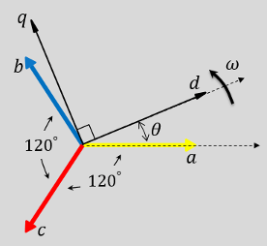

**Fig 2.7 Direction of the magnetic axes of the stator windings in an *abc* reference frame and a rotating *d*-*q* reference**

The DQ to ABC transformation serves the following purposes:

**PWM Signal Generation:** The transformed DQ signals are used to generate the PWM signals, which determine the switching of the rectifier's semiconductor devices (e.g., IGBTs or MOSFETs).

**2.5 PV SYSTEM:**

A Photovoltaic (PV) system is a renewable energy technology that converts solar radiation into direct current (DC) electricity using solar cells composed of semiconductor materials, typically silicon. The PV system consists primarily of solar panels, an inverter, mounting structures, and associated electrical components.

In this project, the PV system serves as a key renewable energy source integrated into the microgrid. Solar panels are installed to capture sunlight and generate electricity during daylight hours. The generated DC power is then converted into alternating current (AC) using a power inverter to ensure compatibility with the microgrid and local load requirements.

The system design takes into account factors such as solar irradiance, panel orientation, tilt angle, temperature coefficients, and system losses to optimize energy output. Additionally, a Maximum Power Point Tracking (MPPT) algorithm is employed to ensure the PV modules operate at their peak efficiency under varying environmental conditions.

The PV system contributes to reducing dependence on fossil fuels, lowering greenhouse gas emissions, and enhancing the sustainability of the microgrid. Its integration with energy storage and other renewable sources ensures a stable and efficient energy supply, even during periods of low solar availability.

**2.5.1 BOOST CONVERTER:**

A **boost converter** is a type of DC-DC power electronic converter that steps up (increases) the input voltage to a higher output voltage while simultaneously reducing the current. In the context of energy management in microgrids, especially those incorporating renewable energy sources (RES) and energy storage systems (ESS), the boost converter plays a critical role in voltage regulation and power conditioning.

In renewable energy applications, the output voltage from sources such as photovoltaic (PV) panels and certain types of fuel cells often varies with environmental conditions and may be lower than the required DC bus voltage of the microgrid. The boost converter is employed to elevate this voltage to a stable level suitable for either direct utilization, battery charging, or further conversion by inverters for AC loads.

Key functions of the boost converter in the microgrid energy management system include:

* **Voltage Regulation**: Ensures that the fluctuating input voltage from intermittent sources like solar panels is converted to a constant DC output.
* **Power Flow Control**: Facilitates controlled energy transfer from renewable sources to the DC bus or to energy storage units.
* **Efficiency Optimization**: Operates at high efficiency under varying load conditions, minimizing power losses and enhancing overall system performance.
* **Integration Support**: Allows seamless interfacing between low-voltage renewable energy systems and higher voltage microgrid infrastructure.

The converter is typically operated under Maximum Power Point Tracking (MPPT) algorithms when connected to PV sources to maximize energy extraction. Additionally, it may be incorporated into the microgrid’s control strategy to respond dynamically to load demands, grid conditions, and storage requirements.

**2.5.2 MPPT ALGORITHM:**

The **Maximum Power Point Tracking (MPPT) algorithm** is a crucial component in the energy management system of a microgrid, especially when integrating renewable energy sources such as solar photovoltaic (PV) systems. The primary objective of the MPPT algorithm is to continuously extract the maximum possible power from the PV array under varying environmental conditions, including changes in solar irradiance and temperature.

The Maximum Power Point Tracking (MPPT)model is integrated with the boost converter to dynamically adjust the operating point of the PV system. The MPPT algorithm continuously tracks the maximum power point, ensuring that the PV system operates at its highest efficiency. In this simulation, the perturb and observe (P&O) algorithm is implemented, which adjusts the duty cycle based on real-time voltage and current measurements from the PV panels.

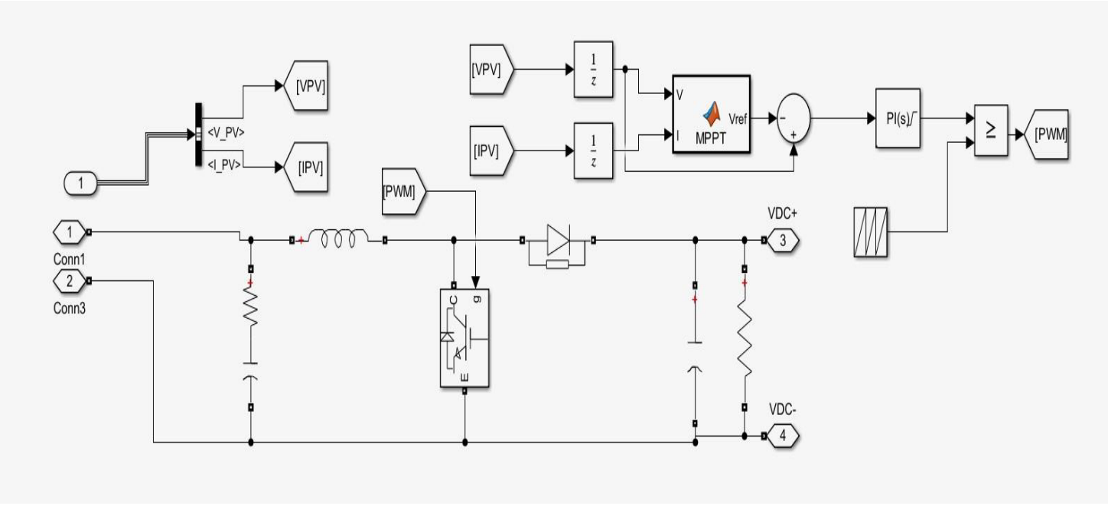

**Figure 2.8: Boost Converter block with MPPT Algorithm**

**2.7 DUAL ACTIVE BRIDGE CONVERTER:**

In the 1990s, the Dual Active Bridge (DAB) converter was introduced to support bidirectional power flow in high-power applications. However, under increased current stress, device costs can rise, and efficiency may drop, potentially leading to device damage. Despite this, DAB converters effectively manage current and enable controlled power flow on both sides of the transformer. A high-frequency transformer is used to provide galvanic isolation between the two DC-DC converter stages.

In fast charging systems, particularly Level 3 DC fast chargers for electric vehicles, high-power DC output is essential to significantly reduce charging time compared to Level 2 chargers. To meet these power requirements, the charger must efficiently convert grid-supplied AC power into regulated DC power for the vehicle battery.

The DAB topology plays a key role in this design, offering several advantages such as soft-switching capabilities, fewer power devices, and high overall efficiency, making it well-suited for modern high-power EV charging systems.

**Features:**

* Single-phase-shift, DAB
* Soft switching
* Bidirectional power flow
* Isolated voltage and current sensing
* PWM switching frequency of 50 kHz
* Transformer size
* Galvanic Isolation
* Modular Design

The DC/DC converter used in EV charging systems must be capable of handling high power levels to meet demanding performance requirements. Additionally, modularity is essential, allowing individual power stage units to be connected in parallel. This modular approach enables the system's output power to be scaled up to meet the varying demands set by DC charging station standards.

Modern charging infrastructure is increasingly adopting converters that support bidirectional power flow. Emerging technologies like Vehicle-to-Grid (V2G) allow energy to flow not only from the grid to the vehicle but also in reverse—from the vehicle’s battery back to the grid. Bidirectional DC/DC converters make this possible by enabling battery charging during forward operation and supplying power back to the grid during reverse operation. This functionality can play a critical role in grid stabilization during peak demand periods.

A 1-phase H-bridge DAB Dc-Dc converter is shown. There are two legs in each H-bridge. On the LV side, there are four switches with four antiparallel diodes. Diodes D1, D2 & D3, D4 have been connected in antiparallel across the switches S1, S2 & S3, S4. Similarly, diodes M1, M2 & M3, M4 have been connected in antiparallel across the switches Q1, Q2 & Q3, Q4. A high-frequency transformer is connected between Two H- Bridges. Input signal Vs 1 is applied through the primary H- Bridge. At time t1 switches S1 & S2 are Turn-on and after 50% delay switches Q1& Q4 are turned on. At the same time t2 switches S2 & S3 are ON. After providing phase shift, switches Q2 & Q3 are on.

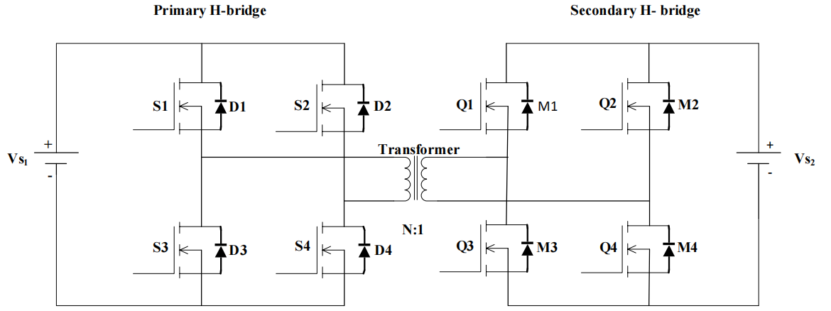

**Fig 2.9 Circuit configuration of DAB dc-dc converter**

**2.7.1 Dual-Active Bridge - Design Considerations**

A number of factors are critical in the design of the power stage of a dual-active bridge. The most important factors are the selection of leakage inductor, desired phase shift of operation, output capacitor rating, switching frequency of operation, selection of SiC MOSFETs, transformer, and intended ZVS range of operation. The selection of the leakage inductor has a direct effect on the maximum power transferred, which in turn affects the phase shift of operation of the converter at the intended power level. Each of these factors are discussed in detail in the following sections:

#### 2.7.1.1 Leakage Inductor

The most important design parameter is the selection of leakage inductor. The power transfer relation of the dual-active bridge is given by

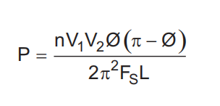

Figure 2-1-3-1 shows the inductor current waveform. The value of current at points i1 and i2 can be derived from this waveform.

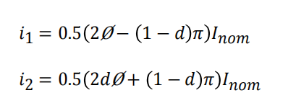

#### 2.7.1.2 Phase Shift

The phase shift of the converter is dependent on the value leakage inductor. The phase shift for required power transfer is given by

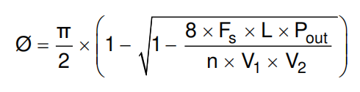

for a small value of inductance, a maximum power transfer at a small value of phase shift is obtained. To have fine control over power transferred, fine high resolution steps in which the phase can be varied must be obtained. Alternatively, a larger inductor can obtain maximum power transfer at a high value of phase shift for better control.

#### 2.7.1.3 Effect of Inductance on Current

In the previous section, it is noted that a high value of leakage inductance can contribute to soft switching up to a very low power level and hence leads to better switching performance. Alternatively, increasing the leakage inductance leads to increased RMS currents in the primary and secondary of the transformer, switch currents, and ripple currents in the capacitor. Figure 1-1-3-2 shows that as the value of leakage inductance increases, the RMS currents in the transformer and switches increase, leading to more conduction losses. Thus, there exists a tradeoff between an optimal value of leakage inductance to affect ZVS and minimizing conduction losses.

#### 2.7.1.4 Switching Frequency

Switching frequency is another important design parameter which affects the efficiency and power density of a power converter. The input and the output voltage levels primarily determine the type of switches used in the power stage. Usage of SiC MOSFETs in the power stage drives the switching frequencies to very high levels. Operating at higher switching frequencies enables reduced size of magnetics which help in improved thermal solution, thereby improving power density of the converter. Therefore, selection of switching frequency is primarily a tradeoff between the allowable heat sink solution and transformer size for a given efficiency target.

Secondly, if the output capacitance (Ecoss) of MOSFET is very high, selection of high switching frequency leads to high switching losses at light load and hampers efficiency. Selection of switching frequency also affects the control loop bandwidth implementation. Considering all of these parameters, 50 kHz was used as the switching frequency for this applications.

## **2.8 CONSTANT CURRENT CONSTANT VOLTAGE CHARGING**

CCCV (Constant Current Constant Voltage) is a battery charging method that involves two stages: an initial Constant Current (CC) phase where the battery is charged at a fixed current, followed by a Constant Voltage (CV) phase where the voltage is held constant and the charging current gradually decreases. This method ensures fast and efficient charging while protecting the battery from overvoltage and overcurrent, making it ideal for lithium-ion batteries and energy storage systems.

Constant Current Constant Voltage (CCCV) charging is a widely used charging method for lithium-ion batteries and other rechargeable energy storage systems. The charging process consists of two main stages: the Constant Current (CC) stage and the Constant Voltage (CV) stage.

In the CC stage, the battery is charged with a fixed current while the battery voltage gradually increases. This phase allows the battery to be charged rapidly and efficiently, typically reaching about 70–80% of its full capacity. Once the battery voltage reaches the predefined maximum (usually the battery’s rated voltage), the system transitions to the CV stage.

During the CV stage, the voltage across the battery terminals is held constant at the maximum safe charging voltage, and the charging current gradually decreases as the battery approaches full charge. This phase ensures battery longevity by avoiding overcharging, which can lead to thermal stress or degradation.

Buck and boost converters are commonly used to implement CCCV charging due to their precise control over output voltage and current. The converter operates in current-controlled mode during the CC phase, where a current feedback loop regulates the output current. Once the battery voltage hits the set threshold, the control mode switches to voltage regulation. In the CV phase, a voltage feedback loop takes over to maintain a steady output voltage while allowing the current to taper down naturally. This dual-loop control ensures safe, efficient, and reliable battery charging, making CCCV an industry standard in EV and energy storage applications.

# **CHAPTER 3: RESULTS AND RESULT ANALYSIS**

# **Result 1: Output voltage of 3 phase Rectifier**

# 

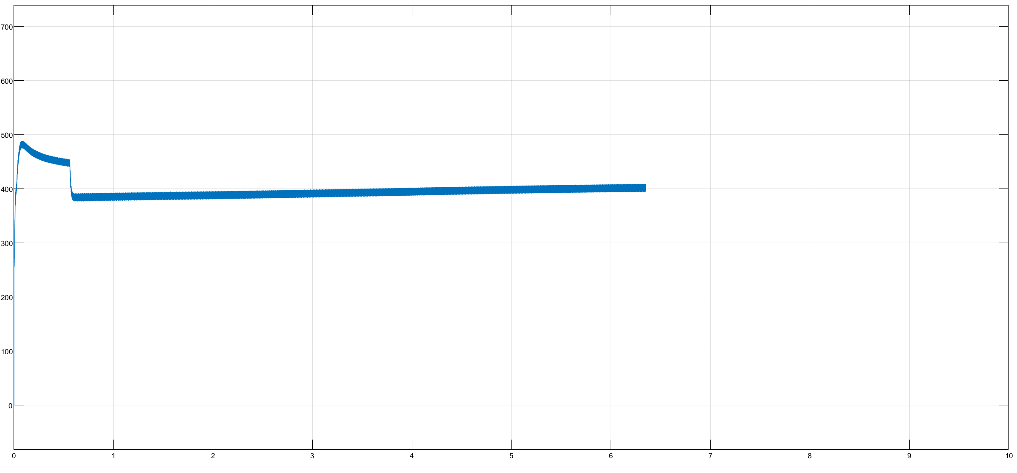

**Fig.3.1: Output Voltage of 3 Phase Rectifier**

**Result Analysis:**

The output voltage waveform of a 3-phase fully controlled rectifier is a pulsating DC waveform composed of segments of the phase voltages, switched in sequence every 60°. Unlike single-phase rectifiers, the 3-phase rectifier offers a much smoother output with less ripple due to the higher pulse frequency (six pulses per cycle in a 6-pulse rectifier).

In this case, with a line-to-line RMS input voltage of 415 V, the average output DC voltage is calculated using:

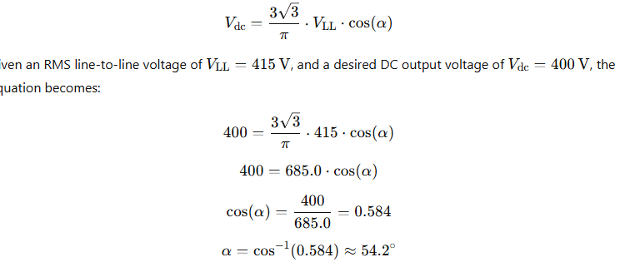

For a firing angle of 54 degrees the desired value of DC voltage of 400V was obtained.

**Result 2: Primary voltage, Secondary Voltage and Inductor current waveform**

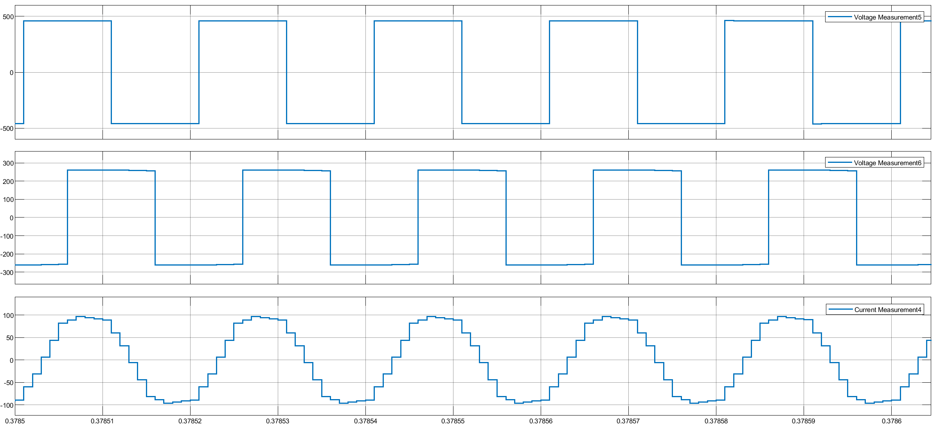

**Fig 3.2: primary, Secondary Voltage and Inductor Current**

**Result Analysis:**

The Dual Active Bridge (DAB) converter produces characteristic square waveforms on both primary and secondary sides, as each full-bridge generates alternating polarity pulses. Power flow direction and magnitude are controlled by the phase shift between these waveforms.. Although primary and secondary voltages have similar amplitudes (based on the turns ratio), their phase difference governs power transfer.The inductor current between the bridges exhibits a near-triangular waveform due to voltage integration across the inductor. It ramps up or down each half-cycle based on the voltage difference. Results confirm efficient, bidirectional power transfer and controllable current, validating the DAB converter’s effectiveness in battery charging applications.

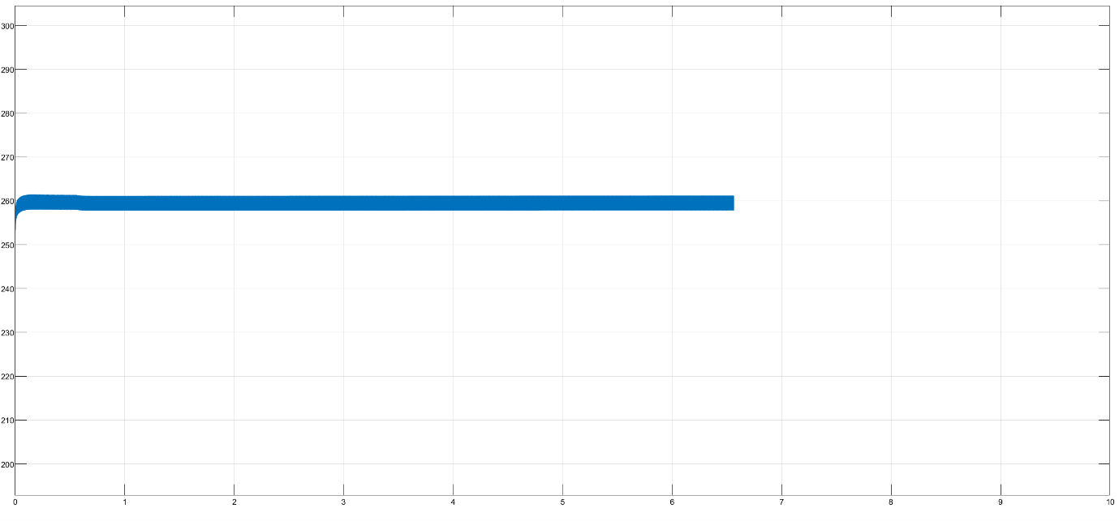**Result 3: Output voltage of DAB Converter**

**Fig. 3.3: Output Voltage of DAB Converter**

**Result Analysis:**

Dual Active Bridge (DAB) converter exhibits characteristic square waveforms for both primary and secondary voltages, as each full-bridge generates alternating polarity pulses. The phase shift between these two voltage waveforms directly controls power flow direction and magnitude. When operating under a positive phase shift, energy transfers from the primary to the secondary side. The primary and secondary voltages maintain similar amplitudes (depending on turns ratio), but their phase difference is the key to regulating power.

The inductor current, which lies between the two bridges, shows a near-triangular waveform due to the integration of the voltage difference across the inductor. During each half-cycle, the inductor current ramps up or down, aligning with the applied voltage difference. The peak and average values of this current depend on the load, switching frequency, and phase shift angle. Results confirm efficient bidirectional energy transfer with controllable current, validating the DAB’s suitability for battery charging applications.

**Result 4: Constant Current Constant Voltage charging**

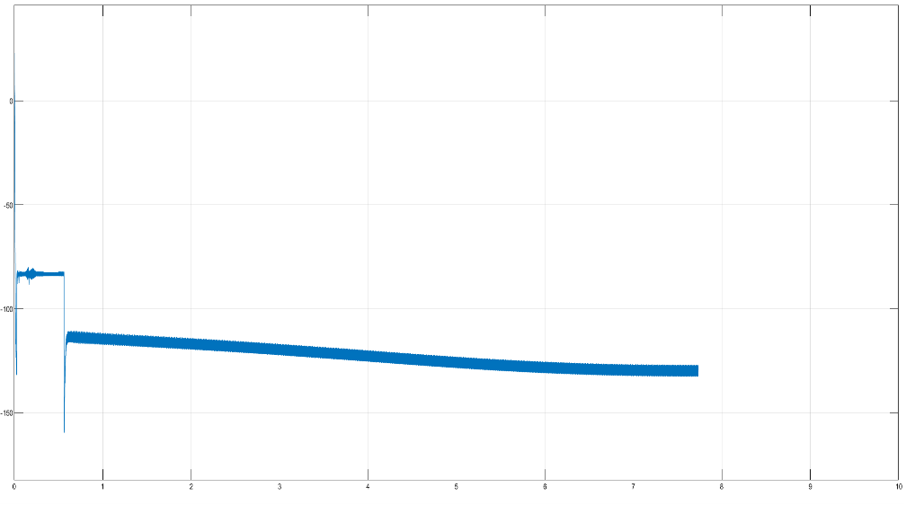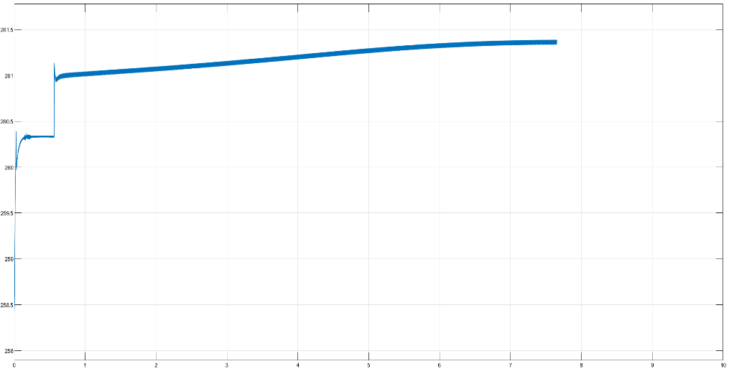

**Fig.3.4.a: Battery voltage Fig.3.4.b Battery Current**

**Result Analysis:**

During the constant current (CC) phase, the battery is charged with a steady current while the terminal voltage gradually rises. The results show a uniform current profile, confirming accurate current regulation by the converter. This phase allows for rapid charging up to approximately 95% of the battery’s SOC. The voltage increases linearly, indicating minimal resistance or thermal stress. This phase ensures efficient energy transfer and reduced charging time without exceeding voltage safety limits.

In the constant voltage (CV) phase, the battery voltage is held constant at the maximum rated level while the charging current gradually tapers off. Results demonstrate a stable voltage plateau with a smooth decrease in current, confirming proper control behavior. This tapering protects the battery from overcharging and heat buildup, ensuring longer life and safety. The converter effectively transitions between CC and CV modes, maintaining precise voltage control as the battery nears full charge.

**CHAPTER 4:**

**CONCLUSION**

This report presents the design and simulation of a Solid-State Transformer (SST)-based Level 3 DC fast charging system incorporating both grid and renewable energy sources. The architecture includes a three-phase controlled rectifier at the input stage to convert AC to DC, supplying power to a centralized DC bus. In parallel, a photovoltaic (PV) array rated at 100 kW is integrated via a DC-DC boost converter, providing clean, renewable energy directly to the system. A Dual Active Bridge (DAB) converter is used downstream of the DC bus to deliver galvanic isolation and efficient voltage regulation to the battery storage units. Two separate batteries, each rated at 60 kW, are charged through the DAB and an additional buck-boost converter respectively, allowing for modular and flexible energy storage. Power factor correction is implemented at the input to ensure unity power factor operation, minimizing reactive power consumption and enhancing grid compatibility. The 3-phase rectifier maintains a constant output voltage of approximately 400 V, while the DAB converter provides a regulated output of 240 V. The combined system achieved a total output power delivery of 120 kW, effectively demonstrating high-speed, high-efficiency EV charging capabilities supported by integrated solar energy.

**FUTURE SCOPES:**

To ensure the long-term safety, performance, and efficiency of grid-connected Battery Energy Storage Systems (BESS), further research and innovation are necessary in the following critical fault domains:

**1. Internal Short Circuit Faults**

Internal short circuits are among the most dangerous and unpredictable failure modes in lithium-ion batteries. These can be triggered by dendrite formation penetrating the separator layer. Future advancements should aim at early detection using embedded thermal sensors, advanced modeling of dendrite growth, and predictive analytics integrated into the Battery Management System (BMS). Additionally, smart materials and thermal shutdown layers could be explored to autonomously block such faults before escalation.

**2. Overcharge Faults**

Persistent overcharging contributes to lithium plating and electrolyte decomposition, increasing the risk of swelling and thermal events. The future scope includes the development of more intelligent BMS algorithms that accurately track State of Charge (SOC) and charge acceptance limits. Implementation of adaptive cut-off mechanisms, predictive voltage clamping, and cell-level monitoring could substantially minimize overcharge damage.

**3. Overdischarge Faults**

Excessive discharge beyond the cut-off voltage results in irreversible electrode degradation and capacity loss. To prevent this, future BESS designs must include predictive discharge algorithms that learn usage patterns and anticipate unsafe voltage thresholds. Enhancing SOC tracking accuracy and integrating real-time load disconnection protocols could protect cells from entering deep discharge zones.

**REFERENCES:**

1] Design and control of an LCL-filter-based three-phase active rectifier Published:IEEE Xplore  
sept.-oct. 2005 by [M. Liserre](https://ieeexplore.ieee.org/author/37272424200); [F. Blaabjerg](https://ieeexplore.ieee.org/author/37278889300); [S. Hansen](https://ieeexplore.ieee.org/author/37273402000)

2] Modeling of three-phase controlled rectifier using a DQ method IEEE *Xplore*: 26 August 2010

by [K. Chaijarurnudomrung](https://ieeexplore.ieee.org/author/37704863900); [K-N. Areerak](https://ieeexplore.ieee.org/author/37545847700); [K-L. Areerak](https://ieeexplore.ieee.org/author/37545847600)

3] Bi-Directional Isolated EV Charger with Reduced Switch Count and DC-link Capacitance”, 2021 IEEE 6th International Conference on Computing, Communication and Automation (ICCCA) by [Muhammad Zarkab](https://ieeexplore.ieee.org/author/37088812746); [Bhim Singh](https://ieeexplore.ieee.org/author/37089309438); [B.K Panigrahi](https://ieeexplore.ieee.org/author/37301106400)

4] "A Review of Fast Charging Solutions for Electric Vehicles" by M. Yilmaz and P. T. Krein, published in IEEE Transactions on Power Electronics, May 2013

5] A Survey on Electric Vehicle Charging Infrastructure Deployment Strategies" by A. S. Masoum, S. Deilami, and P. S. Moses, published in IEEE Transactions on Sustainable Energy, July 2011

6] "Energy Management in Microgrids with Renewable Energy Sources and Energy Storage System" by Ansam B. El-Fawair, Kasim M. Al-Aubidy and Mustafa A. Al-Khawaldeh Published in: IEEE Xplore 6 February 2024

**[7]** Hu Huihui, Liu Kaixuan, Wang Hanqiang, Zhao Rende, Wu Mingbo, Donglei. “A New Fault-tolerant Control of Battery Energy Storage Grid-connected System Based on Cascaded H-Bridge,” *2024 IEEE 10th International Power Electronics and Motion Control Conference (IPEMC-ECCE Asia)*, IEEE, 2024.

**[8]** Chengdong Jiang, Wei Dai, Chuce Guo, Pengbo Han, Jin Liu. “Characterisation of Grid Short-Circuit Faults with Energy Storage Plant,” *2024 IEEE 7th International Conference on Power and Energy Applications (ICPEA)*, IEEE, 2024.

**[9]** Zhicheng Li, Shuling Zhang, Yeqiang Deng, Weijun Zhang, Yuge Chen, Xiaolong Gu, Biao Li, Chaoping Deng, Yu Wang. “Characterization of Short-circuit Faults Within Battery Modules for Energy Storage Systems,” *2024 IEEE 6th International Conference on HVDC*, IEEE, 2024.